ARZANGI: THE PEOPLE OF THE EASTERN CLIME OF LIGHTA Scientific Investigation into the Avestan Roots of Uruzgan, the Arəzahī Clime, and the Origin of Zarathushtra.
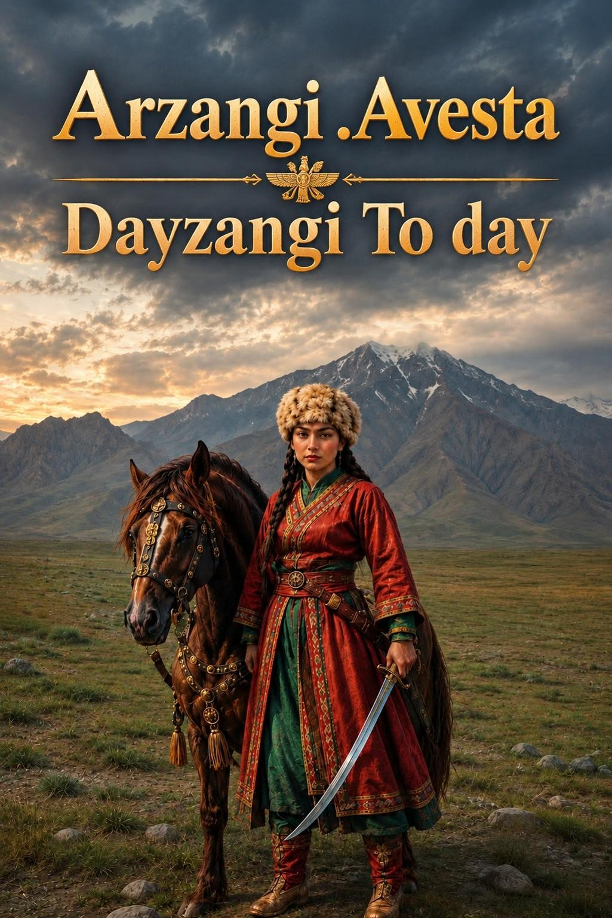
---

Abstract

This study investigates the ancient name Arzangi and its direct connection to the Avestan clime of Arəzahī, the eastern region of first sunrise. The research demonstrates that the name Arzangi derives from Arəzahī, that the Arzangi people inhabited the sacred geography of Airyanem Vaejah (Iranwij) in the central highlands of Afghanistan, and that the modern province of Uruzgan stands as the sole direct geographic heir to this ancient name. The study further establishes that Zarathushtra emerged from this Arzangi community, received his revelation beside the river Dāityā, and began his prophetic mission among the inhabitants of this eastern clime. The evidence derives from the Avesta, Pahlavi texts, the Shahnameh, historical geography, and population genetics.

Keywords: Arzangi, Arəzahī, Airyanem Vaejah, Uruzgan, Zarathushtra, Avesta, Dāityā, Helmand, Iranwij, Bamiyan, Hazarajat, Zoroastrianism

---

1. Introduction

The Avesta divides the world into seven climes known as karshvar. The easternmost clime bears the name Arəzahī. The Mihr Yasht, Yt. 10.15, records that the sun begins its journey from Arəzahī. This clime constitutes the first region illuminated by the rising sun and the first point of contact between the material world and the light of the divine order.

The name Arzangi belongs to this same root. The Arzangi are the people of Arəzahī. They inhabited the eastern clime of light in the central highlands of Afghanistan, in the region known today as Hazarajat. Their name survives in the modern province of Uruzgan, the sole territory that carries a direct linguistic and geographic descent from the ancient Arzangi.

This study traces the full chain of evidence linking Arəzahī to Arzangi, Arzangi to Uruzgan, and Uruzgan to the prophetic mission of Zarathushtra.

---

2. Etymological Analysis: Arəzahī, Arzangi, Uruzgan

2.1. Arəzahī: The Eastern Clime

Arəzahī is the Avestan name for the eastern clime. The root of the word carries the meaning of rising, shining, and dawning. In the Middle Persian tradition, the name appears as Arzah. The Mihr Yasht places this clime at the origin of the sun's daily journey. Arəzahī is therefore the land of first light, the land of dawn, the land of the eastern horizon.

2.2. Arzangi: The People of the Clime

The name Arzangi forms from the root Arz, which is the same root present in Arəzahī. Arzangi means the people of Arz, the inhabitants of the eastern clime, the community of the land of first sunrise. Middle Persian texts record the name Arzang as a geographic and ethnic designation for the population of this eastern region. The Arzangi are therefore the original inhabitants of Arəzahī.

2.3. Uruzgan: The Direct Heir

The modern province of Uruzgan carries the name Arzangan in its older form. The linguistic transformation from Arzangan to Uruzgan follows the regular phonetic shifts of the region. Uruzgan is the sole province of Afghanistan that preserves the name of the Arzangi people in its territorial designation. The province stands as the direct geographic heir to the Avestan Arzangi and, through them, to the clime of Arəzahī.

---

3. The Avestan Sacred Geography: Airyanem Vaejah and the Dāityā

The Vendidad, Fargard 1.1-3, records the creation of sixteen lands. The first land created by Ahura Mazda is Airyanem Vaejah, the Aryan expanse, situated beside the good river Dāityā. Airyanem Vaejah is the first land, the primordial homeland, the place where Zarathushtra received his revelation.

The Zamyād Yasht, Yt. 19.66-69, provides the most detailed geographic description in the entire Avesta. The text names nine rivers, all tributaries of the Haētumant. The Haētumant rises from the Koh-i Baba range in the central highlands of Afghanistan. The Zamyād Yasht identifies this river system as the sacred hydrography of the Avestan world.

Gherardo Gnoli, the Italian Iranologist, established that the entire identifiable geography of the Avesta lies in the eastern Iranian world. Michael Witzel of Harvard University located Airyanem Vaejah in the central highlands of Afghanistan, in the region of Bamiyan and Hazarajat. The convergence of these two independent scholarly traditions confirms the eastern location of the Avestan homeland.

The river Dāityā is the river of the sacred geography. The Dāityā flows through Airyanem Vaejah. Modern geographic identification places the Dāityā at Band-e-Amir in Bamiyan, from which the Helmand system originates. The Avestan sacred geography therefore centers on the central highlands of Afghanistan, the territory of the Arzangi, and the province of Uruzgan.

---

4. Zarathushtra: Origin from the Arzangi Community

4.1. The Avestan Testimony

The Aban Yasht, Yt. 5.17 and Yt. 5.104, records that Zarathushtra sacrificed beside the river Dāityā in Airyanem Vaejah. The Yasna 9.14 identifies Zarathushtra as famous in the Aryan expanse of the good Dāityā. The Yashts 9 and 17 record the same location for the prophet's sacrificial acts.

The Avesta places Zarathushtra in Airyanem Vaejah and beside the Dāityā. Airyanem Vaejah is the territory of the Arzangi. The Dāityā is the river of the Arzangi homeland. Zarathushtra therefore emerged from the Arzangi community and began his mission among the people of the eastern clime of light.

4.2. The Gathic Evidence

The Gathas present the internal testimony of Zarathushtra's own community. The prophet addresses a settled, pastoral society. He speaks of cattle, pasture, and agriculture. He opposes the nomadic raiders and the practitioners of cattle sacrifice. He praises the settled life, the cultivation of the land, and the raising of livestock.

This social profile matches the society of the Arzangi. The Arzangi inhabited the river valleys of the central highlands. Their economy rested on irrigated agriculture and animal husbandry. The Gathas describe this exact social world. Zarathushtra's community and the Arzangi community are one and the same.

4.3. The Linguistic Evidence

The Gathas are composed in Old Avestan, an eastern Iranian language. The language of the Gathas belongs to the eastern branch of the Iranian linguistic family. The Arzangi inhabited the eastern Iranian world. The linguistic identity of the Gathas and the geographic identity of the Arzangi converge in the same eastern territory.

---

5. The Journey to Balkh and the Expansion of the Faith

The Shahnameh of Ferdowsi records the journey of Zarathushtra to Balkh. The prophet traveled from his homeland to the court of Gushtasp, the Kayanian king. The Shahnameh describes the conversion of Gushtasp and the establishment of the Zoroastrian faith in Balkh.

The Zarathusht Nama, a thirteenth-century text, preserves the same tradition. Zarathushtra left his native land, traveled to Balkh, and presented his religion at the royal court. The king accepted the faith and became its royal patron.

Balkh lies in the northern region of the eastern Iranian world. The journey of Zarathushtra from Airyanem Vaejah to Balkh remains within the same eastern cultural sphere. The expansion of the faith moved from the central highlands to the northern plains, both within the territory of the Arzangi and their neighbors.

The later history of the region confirms the eastern identity of the Iranian tradition. The Shahnameh and the Tarikh-e Manzum-e Zabulistan record the resistance of the rulers of Gharjistan against the Ghaznavid Sultan Mahmud. Barazandeh, the ruler of Gharjistan, wrote to Mahmud and declared his descent from Sam, Guderz, Giv, Garshasp, and Hushang. He rejected the Turkic and slave origin of Mahmud and denied the legitimacy of his rule. Gharjistan lies in the central highlands, within the territory of the Arzangi and the Hazarajat.

---

6. Uruzgan: The Direct Geographic Heir

Uruzgan stands as the sole province that preserves the ancient name Arzangan in its modern territorial designation. The name Uruzgan derives from Arzangan, the land of the Arzangi. The province lies in the central highlands of Afghanistan, within the geographic zone of the Avestan Arəzahī and Airyanem Vaejah.

The geographic position of Uruzgan places it at the heart of the sacred geography. The Helmand river system rises in the mountains to the north and east of the province. The Koh-i Baba range, identified with the Avestan Harā Bərəzaitī, lies in the same mountain system. The river Dāityā, identified with Band-e-Amir, rises in the same highland zone.

Uruzgan is therefore the direct territorial heir to the Avestan Arzangi. The province preserves the name, the geography, and the historical continuity of the people of the eastern clime of light.

---

7. Genetic Evidence

The genetic data of Di Cristofaro et al. (2013) provides independent confirmation of the historical continuity of the population of the central highlands. The Hazara population carries haplogroup J2a1-Page55 at a frequency of thirteen percent and haplogroup G2-M201 at a frequency of eight point seven percent. These haplogroups link the population to the Neolithic farmers of the Iranian plateau and the Bronze Age civilization of the Helmand basin.

The Neolithic and Bronze Age layers of the population precede the later steppe and Mongol migrations. The genetic evidence therefore establishes the deep antiquity of the population of the central highlands. The Arzangi of the Avestan period and the modern population of Uruzgan share a continuous biological ancestry in the same territory.

---

8. Conclusion

The name Arzangi derives from Arəzahī, the Avestan clime of the eastern sunrise. The Arzangi inhabited Airyanem Vaejah and the banks of the river Dāityā in the central highlands of Afghanistan. Uruzgan stands as the sole province that preserves the name Arzangan in its modern territorial designation and therefore as the direct geographic heir to the ancient Arzangi.

Zarathushtra emerged from this Arzangi community. He received his revelation beside the river Dāityā in Airyanem Vaejah. He began his prophetic mission among the people of the eastern clime of light. He later traveled to Balkh and converted King Gushtasp. The faith expanded from the central highlands to the northern plains within the same eastern Iranian world.

The evidence derives from the Avesta, the Pahlavi texts, the Shahnameh, the historical geography of the central highlands, and the population genetics of the region. The chain of evidence is continuous. Arəzahī, Arzangi, Uruzgan, and Zarathushtra form a single historical and geographic unity. The people of Uruzgan are the direct heirs to the Avestan Arzangi and to the prophetic tradition of Zarathushtra.

---

References

1. The Avesta: Vendidad (Fargard 1), Mihr Yasht (Yt. 10.15), Zamyād Yasht (Yt. 19.66-69), Aban Yasht (Yt. 5.17, 5.104), Yasna (9.14, 30, 31)
2. Bundahišn and Dēnkard, Pahlavi texts
3. Gnoli, Gherardo. Zoroaster's Time and Homeland. Naples: Istituto Universitario Orientale, 1980
4. Witzel, Michael. "The Home of the Aryans." Harvard University, 2000
5. Di Cristofaro, J., et al. "Afghan Hindu Kush: Where Eurasian Sub-Continent Gene Flows Converge." PLOS ONE, 8(10): e76748, 2013
6. Ferdowsi. Shahnameh
7. Tarikh-e Manzum-e Zabulistan
8. Encyclopaedia Iranica. "Helmand River."
9. Inaba, Minoru. "Yakaulang and Ribat-e Karvan: A Study on the Historical Geography of Northern Hazarajat, Afghanistan." Bulletin of the Society for Near Eastern Studies in Japan, 50(1): 53-79, 2007

